ASSIGNMENT 9
Q1. Implementation of Fractional Knapsack Problem.

Code:
#include <stdio.h>
#include<stdlib.h>

int main() {
int n, capacity;
printf("Enter number of items: ");
scanf("%d", &n);

int w[n], v[n];
double r[n];
printf("Enter weight and value:\n");
for(int i=0; i<n; i++){
scanf("%d %d", &w[i], &v[i]);
r[i] = (double)v[i]/w[i];
}

printf("Enter knapsack capacity: ");
scanf("%d", &capacity);

for(int i=0;i<n-1;i++)
for(int j=i+1;j<n;j++)
if(r[i]<r[j]){
double t=r[i]; r[i]=r[j]; r[j]=t;
int tw=w[i]; w[i]=w[j]; w[j]=tw;
int tv=v[i]; v[i]=v[j]; v[j]=tv;
}

double total=0;
printf("\nSelected items:\n");
for(int i=0;i<n && capacity>0;i++)
{
if(w[i]<=capacity)
{
printf("Item %d: %d (full)\n", i+1, w[i]);
total += v[i];
capacity -= w[i];
}
else
{
double f = (double)capacity/w[i];
printf("Item %d: %d (%.2lf fraction)\n", i+1, capacity, f);
total += v[i]*f;
capacity = 0;
}
}
printf("Maximum value: %.2lf\n", total);
return 0;
}
Output:
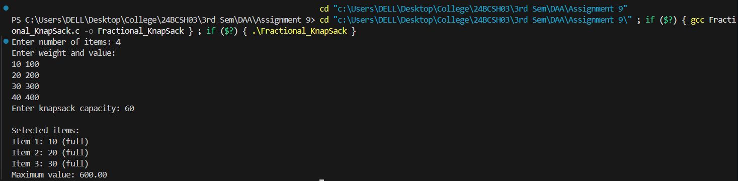

Q2. Implementation of Activity Selection Problem.

#include <stdio.h>
#include<stdlib.h>

int main() {
int n;
printf("Enter number of activities: ");
scanf("%d", &n);

int start[n], finish[n];
printf("Enter start times: ");
for(int i = 0; i < n; i++) scanf("%d", &start[i]);
printf("Enter finish times: ");
for(int i = 0; i < n; i++) scanf("%d", &finish[i]);

for(int i = 0; i < n-1; i++)
for(int j = i+1; j < n; j++)
if(finish[i] > finish[j]) {
int t = finish[i]; finish[i] = finish[j]; finish[j] = t;
t = start[i]; start[i] = start[j]; start[j] = t;
}

printf("Selected activities:\n");
int lastFinish = 0;
for(int i = 0; i < n; i++) {
if(start[i] >= lastFinish) {
printf("Activity %d (Start: %d, Finish: %d)\n", i+1, start[i], finish[i]);
lastFinish = finish[i];
}
}
}
Output:
